海盗船 --- GP2YA21传感器避障功能

Pirate: GP2YA21 Obstacle Avoidance

在完成基础功能后，我们对机器人来个升级，给它增加避障功能。避障功能，是机器人最基础的功能之一，也是机器人体现自主意识的第一步。机器人能够识别前方的障碍物，并避开障碍物。我们这里用到的是GP2YA21传感器传感器，这是一款模拟传感器，与数字传感器的区别在于，在距离检测上更为精准。输出的不只是“有”和“没有”这两个信号。可帮助机器人看到前方的物体。

After assembling the Pirate and completing its basic features, we’re ready for an upgrade: obstacle avoidance capabilities.

After assembling the Pirate and completing its basic functions, we’re ready for an upgrade: obstacle avoidance capabilities. Obstacle avoidance is among a robot’s most fundamental capabilities, as it enables the robot to recognize and avoid obstacles that lie in its path. Here, we’ll be using the GP2YA21 sensors: compared to normal digital sensors, the GP2YA21’s distance detection is more precise; rather than just outputting “Yes/No” signals, the GP2YA21 can feed more detailed information to your car, which helps avoid objects in its path.

硬件材料：

Hardware components

* GP2YA21距离传感器 × 1

GP2YA21 distance sensors x 1

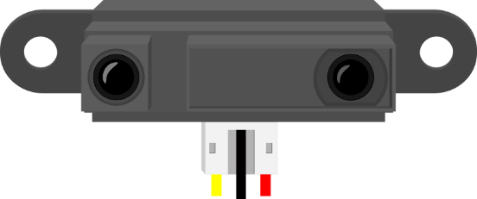

* DF05BB 5.1Kg 机器人专用舵机

DF05BB 5.1Kg robot servo

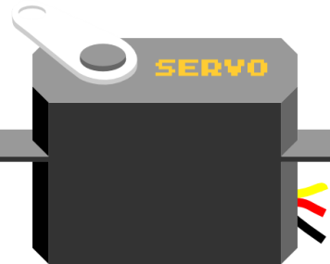

* 夏普GP系列红外传感器支架

GP infrared sensor support frame

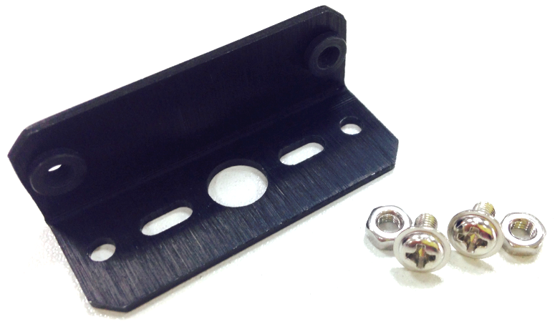

组装步骤

Assembly Directions

找到所有硬件材料后，就开始组装了，组装不难，更着操作就行。

After finding the necessary parts, you’re ready to start assembling. Assembly won’t be too difficult – just follow the directions below and you’ll have no problems.

STEP 1: 摆放材料

Step 1: Sort out and arrange materials

找到以下几个元件，使用的螺丝是舵机零件包所配的自攻螺丝。

First, find and sort out all the materials from your parts bag. You’ll find the necessary screws and bolts in the separate bag containing the robot servo parts.

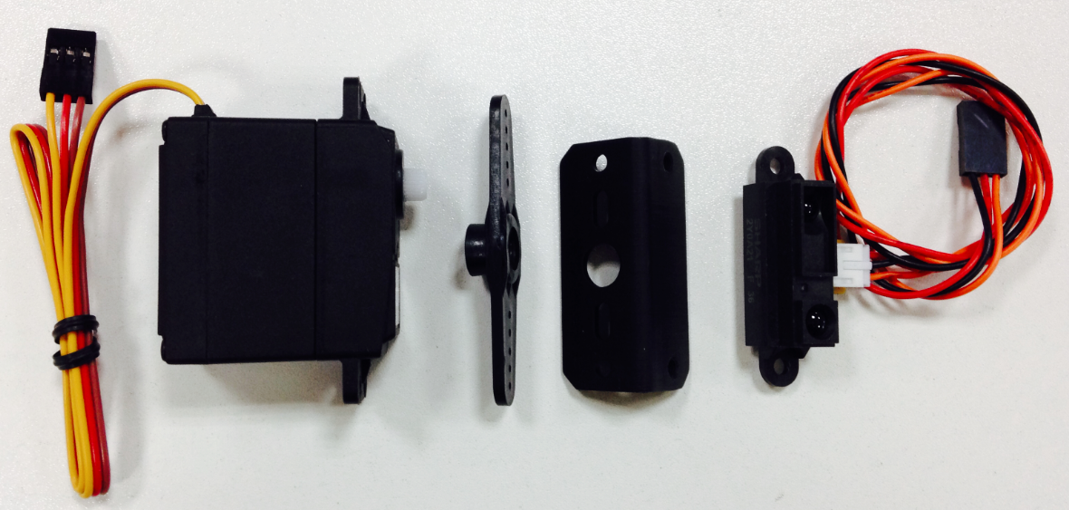

STEP 2: 安装舵盘

Step 2: Assemble the servo

找到舵机零件包中最长的自攻螺丝，用来安装舵盘。

Find the necessary screws to attach the servo horn to your servo. Screw in the horn as shown below.

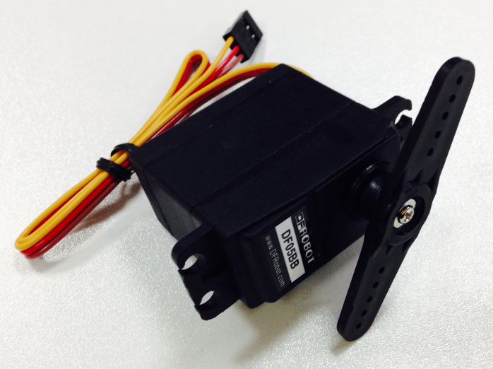

STEP 3: 固定红外支架

Step 3: Attach the IR sensor support frames

这里同样需要使用到自攻螺丝，找到支架的对应孔位，拧上螺丝。

Use the necessary screws to attach the IR sensor support frames to the servo.

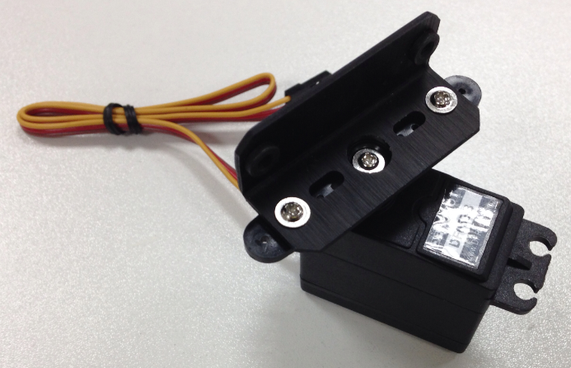

STEP 4: 安装红外传感器

Step 4: Assemble the IR sensors

红外支架上有传感器的两个对应孔位，用M3的螺丝和螺母来固定。完成后的样子。

Use the provided M3 nuts and bolts to mount the sensors onto the two holes on the support frame — see below.

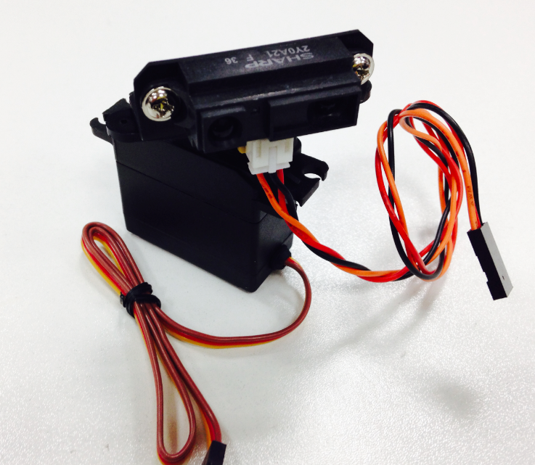

STEP 5: 固定红外传感器

Step 5: Attach the IR sensors

红外传感器和舵机固定完成后，还需要将其安装到小车的上层板上。同样是4个M3螺丝和螺母，找到上层板上的4个舵机固定孔位，拧上即可。

After attaching the sensors to the servo, we now need to attach the servo to the top plate of the Pirate. After finding the four appropriate holes on the top plate, use four M3 screws and nuts to screw the servo into place.

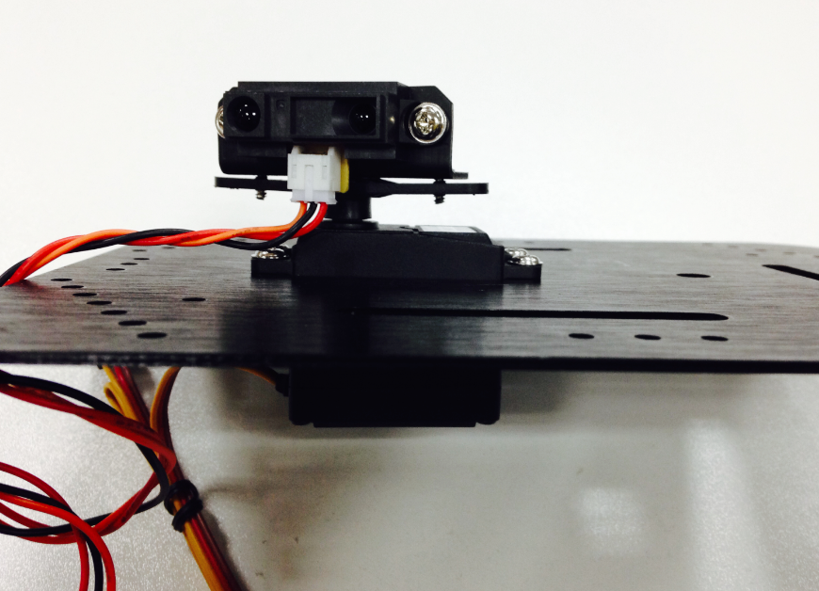

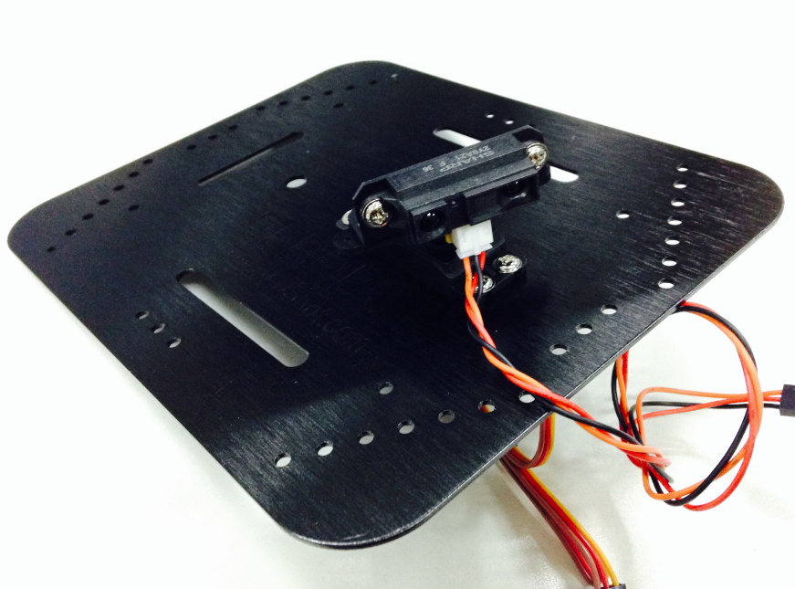

恭喜你，你基本已经完成安装了！先不要急着将上层板固定上去，因为传感器和舵机还没有接线。

Congrats, you’ve completed the first step in installing your sensors! Before attaching the top plate back onto the Pirate, we still need to solder the wires onto the microcontroller.

硬件连接

Connect the hardware

这里的接线非常容易，直接插上我们的3pin接口就可以了。舵机连接到数字口3，红外距离传感器连接到模拟口5。连接时，注意线序。

Soldering the servo and sensors here is fairly straightforward.

For the servo, solder the three wires to digital port 3.

For the sensors, solder the three wires to analog port 5.

Refer to the diagram below when soldering — make sure to pay attention to the proper sequence in soldering each wire.

舵机 – D3 (黄色 – 信号线, 红色 – VCC, 棕色 – GND)

Servo - D3 (Yellow: Signal wire, Red: VCC, Brown: GND)

GP2YA21距离传感器 – A5 (橘色 – 信号线, 红色 – VCC, 黑色 – GND)

GP2YA21 Sensors - A5 (Orange: Signal wire, Red: VCC, Black: GND)

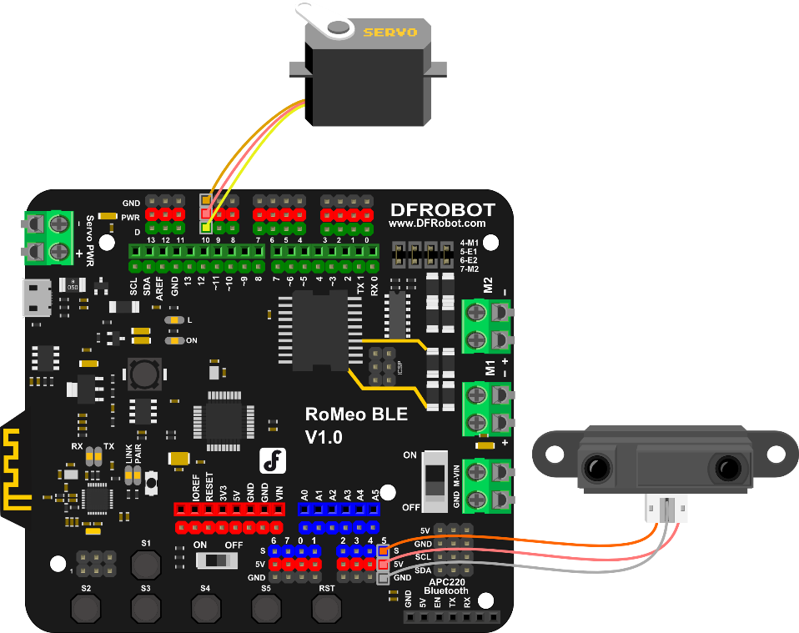

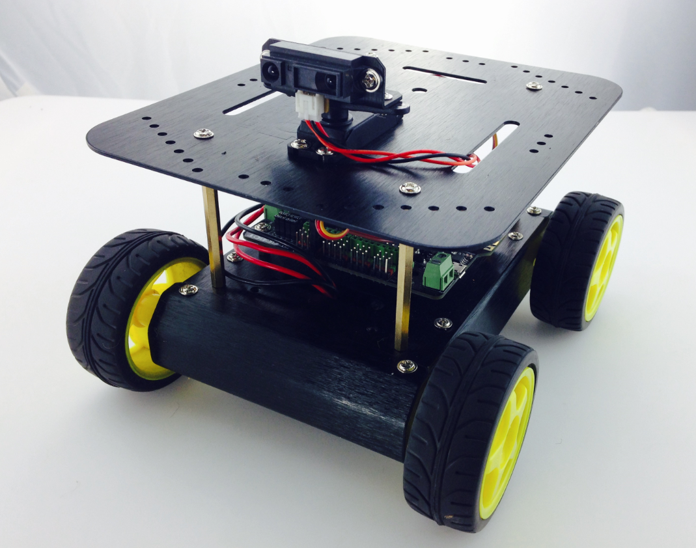

传感器调试

Adjust the sensors

舵机调试

Servo adjustment

舵机在开始使用的时候，我们需要对舵盘位置进行初始化，通常初始化为90°。如何设置呢？硬件连接不变，下载代码包中的Servo_Test.ino的样例代码。

In setting up our servo, we first need to configure and initialize it for use — in this case, we want to configure it to a 90° angle. How do we configure our servo? First, download and run the “Servo_Test.ino” sample code.

#include <Servo.h>

Servo myservo; // create servo object to control a servo

void setup() {

myservo.attach(10); // attaches the servo on pin 3

}

void loop() {

myservo.write(90); // tell servo to go to position in 90

delay(15); // waits 15ms

}

下载完成后，舵机是不是转到某个角度了？ 比如如下图所示：

After downloading the code and running it, your servo should switch angles like in the picture below:

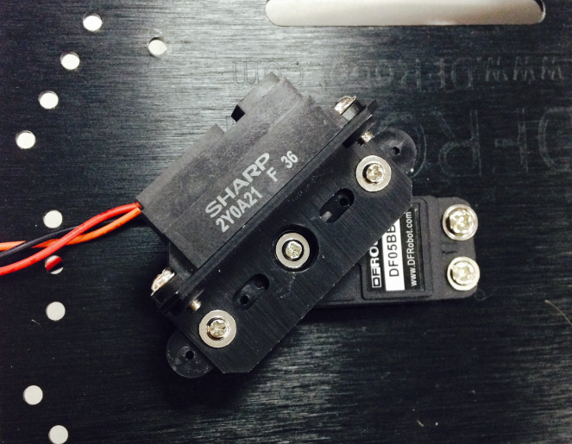

此时，不要拔下USB线！你需要做的事，拧下中间固定舵盘的螺丝。

During this process, do not unplug your USB cord! Instead, unscrew the middle screw attaching the servo in place.

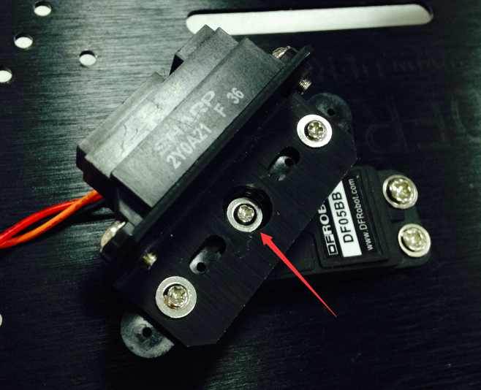 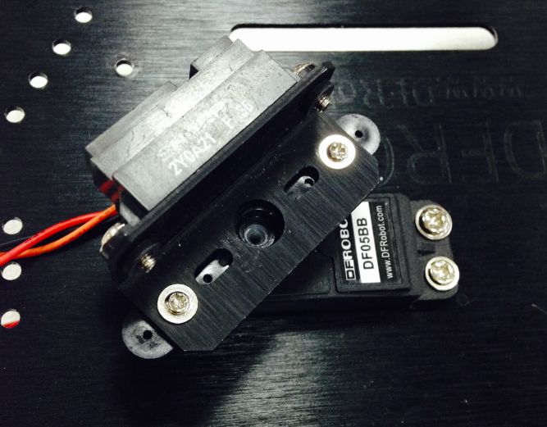

轻轻转动舵盘，你会发现舵盘转不动了。那是因为代码将舵机保持在了90°位置，舵机被锁住了。切记不要强行扳动舵盘！再次拧下舵盘上的螺丝。

If you try to gently prod the servo, you’ll discover that it’ll refuse to budge. This is because we’ve configured the code to keep the servo at a 90° position; the servo is locked at this angle. With this in mind, be sure not to forcibly pull or tug at the servo! Next, remove the middle screw holding the sensors in place.

拔下固定在舵机上的红外传感器，重新摆放位置，将传感器置于小车的正前方。摆放完成后，重新拧上舵机螺丝。

Remove the sensors attached to the servo. Place the sensors on the front of the car (shown in the picture below). After moving the sensors, re-screw the servo’s middle screw.

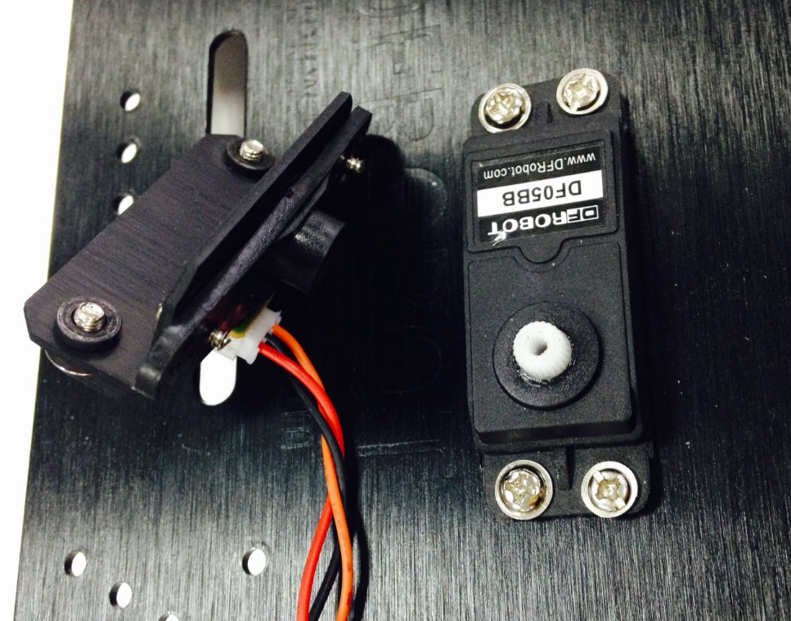 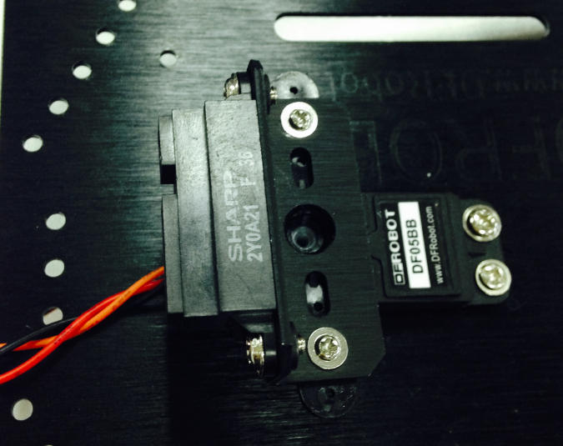

输入代码

Coding

由于代码较长，所以这里就不全部显示出来，你可在软件包中找到Avoidance_GP2Y0A41.ino的代码，下载进去后即可。

Since the length of the code is relatively long, we won’t delve into all the specifics. . Download and run the Arduino code “Avoidance_GP2Y0A41.ino.”

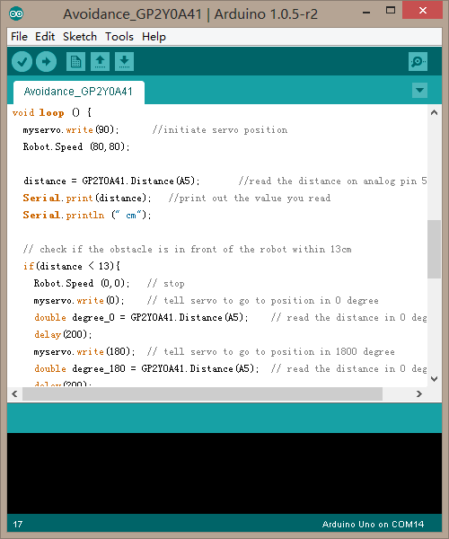

下载完成后，你就可以看到小车的避障效果了。当然，如果你觉得检测距离还不是很满意，也可以做一些微调。直到能正常工作。玩过之后，我们就来简单看下避障原理以及学习下代码，便于你能更好的改造你的机器人！

After downloading the code, upload it to your Romeo microcontroller. Once your car starts moving, you’ll be able to see the obstacle avoidance sensors in action. If you feel like the sensor’s distance detection isn’t sufficiently strong, feel free to further adjust the sensors.

Next, we’ll briefly go over the concepts behind obstacle avoidance — this way, you’ll be better able to understand and modify the code on your own.

避障原理

Obstacle avoidance: how it works

通过下面a，b，c，d，e，f来简单看下如何通过三个传感器来实现避障。在前方没有障碍物，小车前行（图a）。一旦检测到前方有障碍物，先让小车停下，并且舵机转到0°检测下（图b），再让舵机转到180°，再检测下前方物体（图c）。判断一下，0°和180°前方障碍物的距离哪个更近，图中0°的距离更近。所以，小车开始执行后退（图d）,并且右转（图e）。直到前方不再有障碍物，小车恢复前行（图f）。

The following six diagrams (A, B, C, D, E, F) briefly illustrate how the three sensors work to avoid obstacles. At first, the car moves forward uninhibited (diagram A). Once it detects an obstacle, the sensors command the car to stop; the servo will shift to 0°, survey its surroundings (diagram B), then shift to 180° and survey its surroundings once more (diagram C). The sensors will process the readings from the 0° and 180° angles to determine which direction the nearest obstacle is in — in the case of the below diagrams, that would be the obstacle in the 0° reading (diagram B).

In light of that reading, the car will reverse (diagram D) and then turn right (diagram E) until it senses no objects in front of it; then, the car will continue to move forward (diagram F).

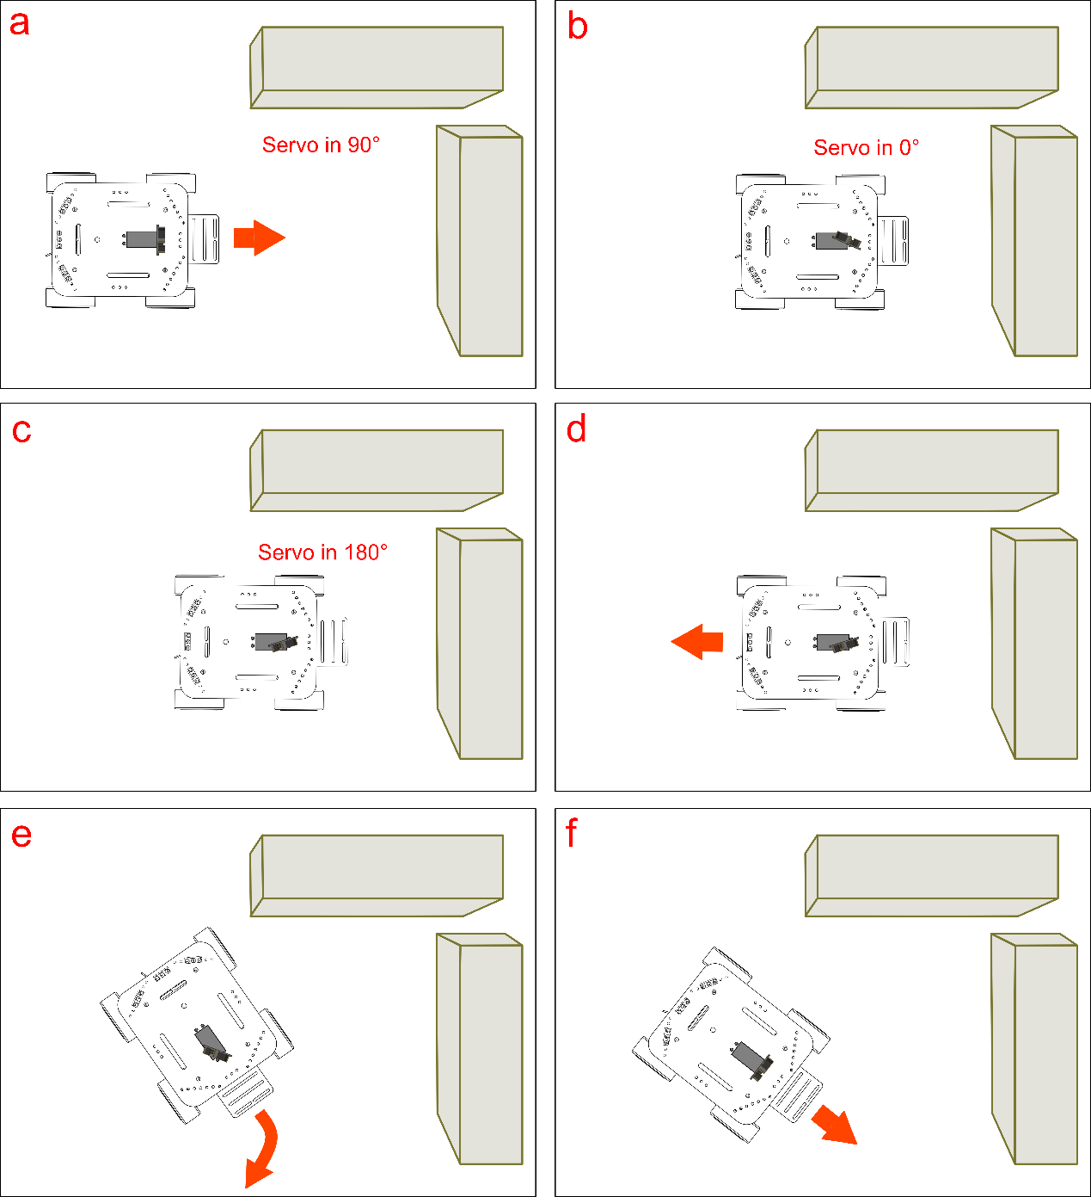

代码回顾

Code Synopsis

基础功能重复部分就不说了，只说下避障部分的。这里又用到，两个库Servo，GP2Y041。Servo库是用来控制舵机的。GP2Y041库则是传感器用来检测距离的库。 There’s no need to discuss the basic code – let’s just take a look at the part involving obstacle avoidance.

Here, we’ll be using two Arduino libraries — Servo and GP2Y041. The Servo library is used to control the servo, while the GP2Y041 library is used for the sensor’s distance detection.

#include<Servo.h>

Servo myservo; // create servo object to control a servo

我们在使用Servo库时，需要一开始对这个库声明一个对象myservo。

In order to use the Servo library, we must declare myservo as an object in the void setup() portion of our code.

#include <GP2Y0A41.h>

InfraredSensor GP2Y0A41;

long distance;

同样我们用红外距离传感器时，也需要声明一个对象GP2Y0A41，（GP2Y0A41是红外传感器型号）。变量distance是来存储红外传感器读到的值。

We also have to declare GP2Y0A41 as an object in order to initialize our sensor’s distance detection. The distance variable is used to store the readings from our sensors.

再看setup()函数中，电机部分由于在基础功能一节已有介绍，所以不做说明，如不明白，可以跳回到基础功能一节。我们主要看下舵机部分。

We won’t rehash the void setup() part of the code since we previously discussed this in the Basic Functions portion of this guide. Below, we’ll discuss the code that relates to the servo.

myservo.attach(10);

这句话是用来设置舵机引脚的，因为我们这里舵机接的是数字口10，所以代码中对应写入引脚10。当然，你也可以改为其他引脚，代码中也要做相应的修改。

This line of code is used to configure the pin/port responsible for the servo. Since we soldered our servo to digital port 10, our code here initializes digital port 10. If you wire your servos to a different pin/port (i.e. port 11) and change your code accordingly (myservo.attach(11)), that will also work.

函数格式如下：

The function is as follows:

myservo.attach(pin);

这个函数就是用来初始化舵机的引脚的。

This function is used to initialize the servo pin.

接着往下，我们用到串口了，串口是什么？串口是Arduino和电脑之间通信的一种渠道。Arduino可以通过串口将数据发送给电脑，电脑也可通过串口将数据发送给Arduino。我们这里就是通过串口将Arduino从红外传感器中读到的数据发送给电脑。

在使用串口的时候，必须在setup()函数中进行一个类似于初始化的设置，也就是：

After initializing the servo pin, we want to use the Serial function. What does Serial do? Simply put, it’s a channel for Arduino to communicate with the computer. Arduino uses Serial to send digital data to the computer — the computer can also use Serial to send digital data back to Arduino. Here, we use the function to enable Arduino to send the sensor’s digital readings to the computer.

When using the Serial function, be sure to place it in the void setup() portion of your code.

Serial.begin(9600);

函数格式：

The function is as follows:

Serial.begin(speed);

该函数有一个参数speed，是用来设置波特率的。在一些特定的无线通信模块需要有一些特殊设置。如果只是串口打印数值，无需太在意。

This function has one parameter, speed, which is used to set the baud rate. When using certain wireless modules, we need to apply baud rate settings. But if we just input a number using Serial, this doesn’t pose any problem.

程序走到主函数loop()，这部分内容最好结合上面的避障原理可能会更容易理解。先来看几个陌生的函数。

The above function should be placed in the void loop() portion of your code.

Let’s take a look at some new functions.

myservo.write(90);

函数格式：

The function is as follows:

myservo.write(pos);

该函数是用来设置舵机角度。参数pos就是写入的角度值。

This function is used to configure the angle of the servo. The pos value corresponds to the angle that you want to fix the servo at (i.e. 0~180°).

当然这个角度也不是随便设置的，需要根据你选舵机决定的。我们这里选择的是180°舵机，所以可设角度也应该为0~180°之间。所以，这里舵机角度为90°。小车正常前行。接着往下，我们需要读取距离前方物理有多远距离。

We don’t want to set a random value for this function — optimal values are determined by the type of servo used. Here, we use an 180° servo; thus, we can select any value between 0~180°. In this case, we’ll input 90° as our value.

distance = GP2Y0A41.Distance(A5);

这个语句的意思是，我们从引脚5（连接传感器的引脚）读取距离。并把读到的值通过distance存储起来。

This function determines how far obstacles are from your car. We use analog pin 5 (the pin connected to our sensors) to read and detect distance. Then, we use the distance function to store this reading.

函数格式：

The function below:

GP2Y0A41.Distance(analogPin);

这个函数只有一个参数analogPin，模拟口引脚。用于读取红外传感器的距离值。

This function only has one parameter, analogPin. It’s used to read the distance values given by our sensors.

如果我们想在电脑上看到具体读到的值是多少呢？就可以用下面两句话：

If we want to directly read these values on your computer, we can use the following two lines of code:

Serial.print(distance); //print out the value you read

Serial.println (" cm");

串口print的输出方式有很多，具体参看[语法手册](http://wiki.dfrobot.com.cn/index.php/arduino%25e7%25bc%2596%25e7%25a8%258b%25e5%258f%2582%25e8%2580%2583%25e6%2589%258b%25e5%2586%258c%25ef%25bc%2588%25e5%25a4%259a%25e9%25a1%25b5%25e9%259d%25a2%25e7%2589%2588%25ef%25bc%2589)。

Serial.print can be used in many different manners — for more info, check out the Terminology Manual or the official Arduino website.

接下来，我们就要开始做判断了，判断前方障碍物是不是距离太近了，小于我们设定的13cm了，如果小于13cm了该怎么做？大于13cm该怎么做？也就是这里用到的if…else的语句。

Next, we’ll be dealing with the code that determines object distance. The code sets out to determine how close an object is — here, we’ve set a parameter for how the car should move if an object is within 13 cm of the car or further than 13 cm from the car. To do this, we need to use the if…else function.

我们以通俗的话先来看下避障原理中涉及的逻辑分析。

Let’s check out the following to get a better sense of the logic behind obstacle avoidance.

if（距离 < 13）{

小车停下；

舵机转到0°；

读取0°位置障碍物的距离；

再转到180°；

读取180°位置障碍物的距离；

if（0°位置距离 > 180°位置距离）{

小车后退；

小车右转；

}

else{

小车后退；

小车左转；

}

}

else{

小车正常前进；

}

不知道以这样的形式，你是不是明白了，小车在碰到障碍物的时候是怎么处理的。中间有个0°位置和180°位置的判断，这是用来判别是左右两边哪个距离障碍物更近，使其朝相反方向运动。

This code illustrates the principles in the “Obstacle avoidance: how it works” section of this guide. Simply put: if the object is detected less than 13 cm away from the sensors, then the car will stop. Then, the servo will rotate to a 0° and 180° angle, respectively. The sensors will process the readings from the 0° and 180° angles to determine which direction the nearest obstacle is in — after making that determination, that car will reverse, then turn left or right until it senses no obstacles in its path, whereupon it will move in a forward direction again.

如何串口看数值？

How do we use Serial to observe the sensor’s values?

前面还保留了一个问题就是，我们如何从串口来看数值呢？在Arduino IDE上有个Serial Monitor（串口监视器）。

As mentioned before, we can use the Serial function to see the readings given by the sensors. The Arduino IDE has a Serial Monitor which can be used to track those readings as they’re being fed back to the computer.

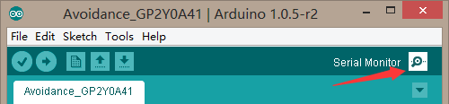

下载完代码后，点击一下，就会跳出如下的一个对话框。右下角有个下拉框，则是可以选择串口波特率的，需要与代码中保持一致。所以我们这里串口设置为9600。

After downloading the code and opening the Arduino IDE, click on the button labeled “Serial Button” as shown in the picture above. A box will appear. In the bottom right corner of that box is a drop-down menu that lets you select the baud rate. In selecting the baud rate, we want to be consistent with what we wrote in our code (i.e. Serial.begin(9600)). Since we wrote Serial.begin(9600) before, we want to select a 9600 baud rate in the drop-down menu.

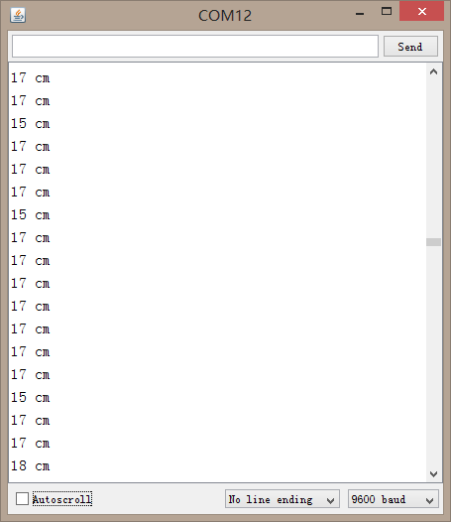

这样，你就可以根据读到的值，在代码中相应的修改。我们代码中设置的是13，你完全可以根据自己的需要设置为17等。

Based on the values of your sensors’ readings, you can tweak and modify your code to your liking. We’ve set our code to detect and respond to objects at a distance of 13 cm, but you can adjust your code to a value of 17 cm or whatever you prefer.

但需要记住的一点是我们这个传感器的检测范围在4~30cm，所以不要超过30cm就行啦！当然也不要小于4cm。

Something to keep in mind: our sensors have a distance detection range of 4 to 30 cm; as such, make sure you don’t set your code to detect objects beyond 30 cm or below 4 cm.

大改造

代码就讲到这里，我们这里做的是一个避障机器人。其实，同样的传感器，改造一下就能成为跟踪机器人了。只是方式相反，这里是，检测到物体后避开，跟踪的话，则是检测到物体后，向物体方向靠近。想一下，给自己做个跟踪机器人。

Interestingly, we can apply these same sensors to give our robot “tracking” capabilities. Unlike obstacle avoidance, which seeks to avoid detected objects, tracking capabilities command your car to follow an object once detected. Obstacle avoidance, tracking – these are powerful features that allow you to get creative. With this in mind, get to tinkering and having fun!